PROGRAM-9
. Problem Statement
Students must satisfy several requirements to become eligible for a final examination. These requirements may include minimum attendance, laboratory completion, internal assessment marks, and fee clearance. This case study aims to develop a Python program that evaluates these conditions, determines whether a student is eligible for the final examination, and reports every unmet requirement.
2. Objectives
- To check student examination eligibility using multiple conditions.
- To validate attendance percentage.
- To check laboratory completion status.
- To verify internal assessment marks.
- To check fee payment status.
- To display the final eligibility result.
- To identify and report all unmet requirements.
3. Assumptions
- Minimum required attendance is 75%.
- All laboratory work must be completed.
- The minimum internal assessment mark is 20 out of 40.
- All examination fees must be paid.
- A student is eligible only if all four requirements are satisfied.
- Attendance must be between 0% and 100%.
- The program uses basic Python variables, conditional statements, and logical operators.
4. Algorithm
- Start.
- Input the student's attendance percentage.
- Input laboratory completion status.
- Input internal assessment marks out of 40.
- Input fee payment status.
- Validate the attendance and internal marks.
- Check whether attendance is at least 75%.
- Check whether all laboratory work is completed.
- Check whether internal marks are at least 20.
- Check whether all fees are paid.
- Record every unmet requirement.
- If no requirements are unmet, display “Eligible for Final Examination.”
- Otherwise, display “Not Eligible” and list the unmet requirements.
- Stop.
5. Flowchart
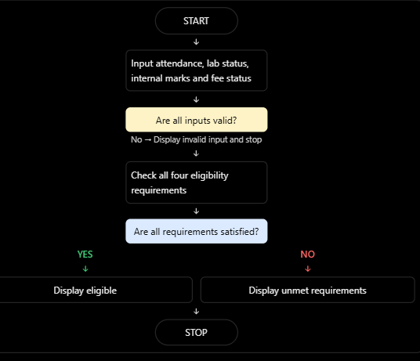
6. Pseudocode
START

INPUT attendance
INPUT laboratory_status
INPUT internal_marks
INPUT fee_status

IF attendance < 0 OR attendance > 100
OR internal_marks < 0 OR internal_marks > 40:
DISPLAY "Invalid input"
ELSE:
unmet_requirements = empty list

IF attendance < 75:
ADD "Insufficient attendance"

IF laboratory_status is not completed:
ADD "Laboratory work incomplete"

IF internal_marks < 20:
ADD "Insufficient internal marks"

IF fee_status is not paid:
ADD "Fees not paid"

IF unmet_requirements is empty:
DISPLAY "Eligible for Final Examination"
ELSE:
DISPLAY "Not Eligible"
DISPLAY all unmet requirements

STOP

7.Python Source Code

attendance = float(input("Enter attendance percentage: "))
lab = input("Are all laboratory works completed? (yes/no): ").lower()
marks = float(input("Enter internal marks out of 40: "))
fees = input("Are all fees paid? (yes/no): ").lower()

if (attendance < 0 or attendance > 100 or
marks < 0 or marks > 40 or
lab not in ["yes", "no"] or
fees not in ["yes", "no"]):
print("Invalid input")

else:
unmet = []

if attendance < 75:
unmet.append("Insufficient attendance")

if lab != "yes":
unmet.append("Laboratory work incomplete")

if marks < 20:
unmet.append("Insufficient internal marks")

if fees != "yes":
unmet.append("Fees not paid")

if len(unmet) == 0:
print("Eligible for Final Examination")
else:
print("Not Eligible for Final Examination")
print("Unmet Requirements:")

for requirement in unmet:
print("-", requirement)
8.Test Cases
Test | Attendance | Lab completed | Marks / 40 | Fees paid | Expected result
1 | 85% | Yes | 35 | Yes | Eligible
2 | 60% | Yes | 30 | Yes | Insufficient attendance
3 | 80% | No | 25 | Yes | Laboratory work incomplete
4 | 90% | Yes | 15 | No | Insufficient marks and fees not paid
5 | 70% | No | 10 | No | Not eligible; four unmet requirements
6 | 110% | Yes | 30 | Yes | Invalid input
9.Output Screenshots
Enter attendance percentage: 70
Are all laboratory works completed? (yes/no): no
Enter internal marks out of 40: 10
Are all fees paid? (yes/no): no
Not Eligible for Final Examination
Unmet Requirements:
- Insufficient attendance
- Laboratory work incomplete
- Insufficient internal marks
- Fees not paid

10. Conclusion
Thus, the Python program successfully determines a student's eligibility for the final examination by checking attendance, laboratory completion, internal assessment marks, and fee payment status. It displays the eligibility result and identifies all unmet requirements. This case study demonstrates the use of conditional statements, logical operators, lists, and loops in Python.

